# **Linear Classifiers**

## **Restaurant Review System**

The review is from a customer who likes Sushi.  
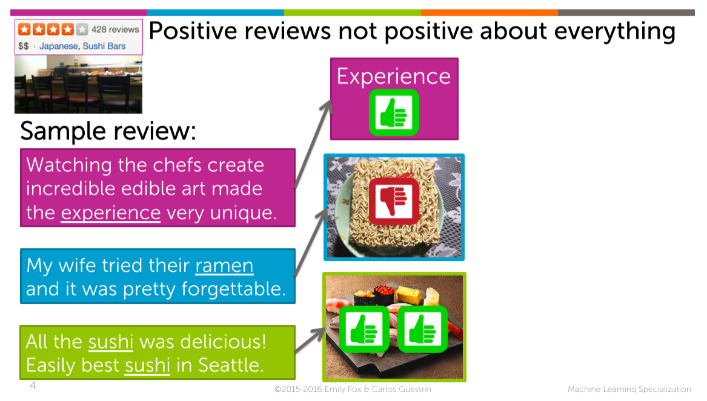

Every review has a different aspects and different sentences.   
I would like to capture a sentiment of each sentence so I can understand if it’s good with respect to Sushi which is what I care the most.

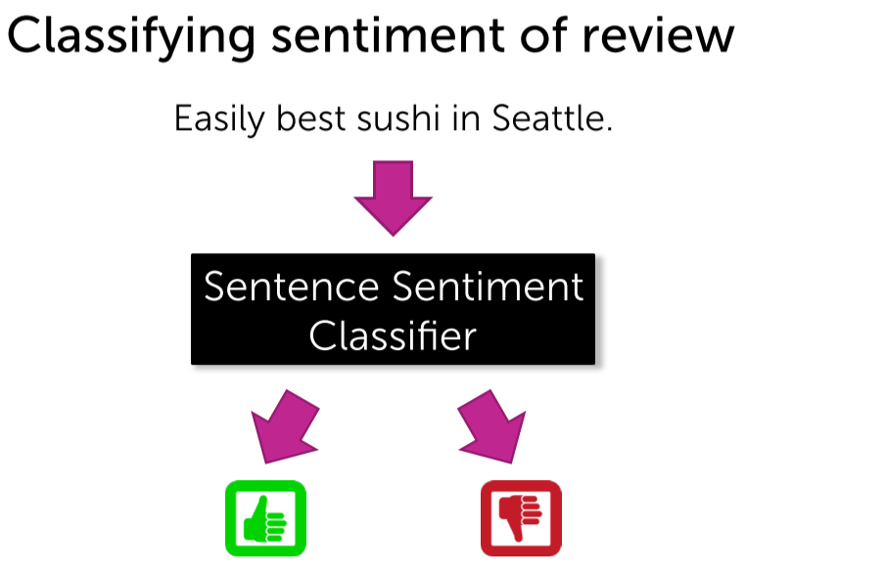

## **Intuition behind Linear Classifier**

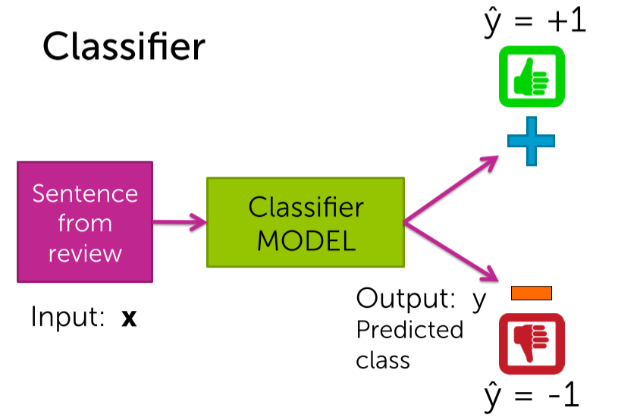

How positively/negatively influential this word is ??

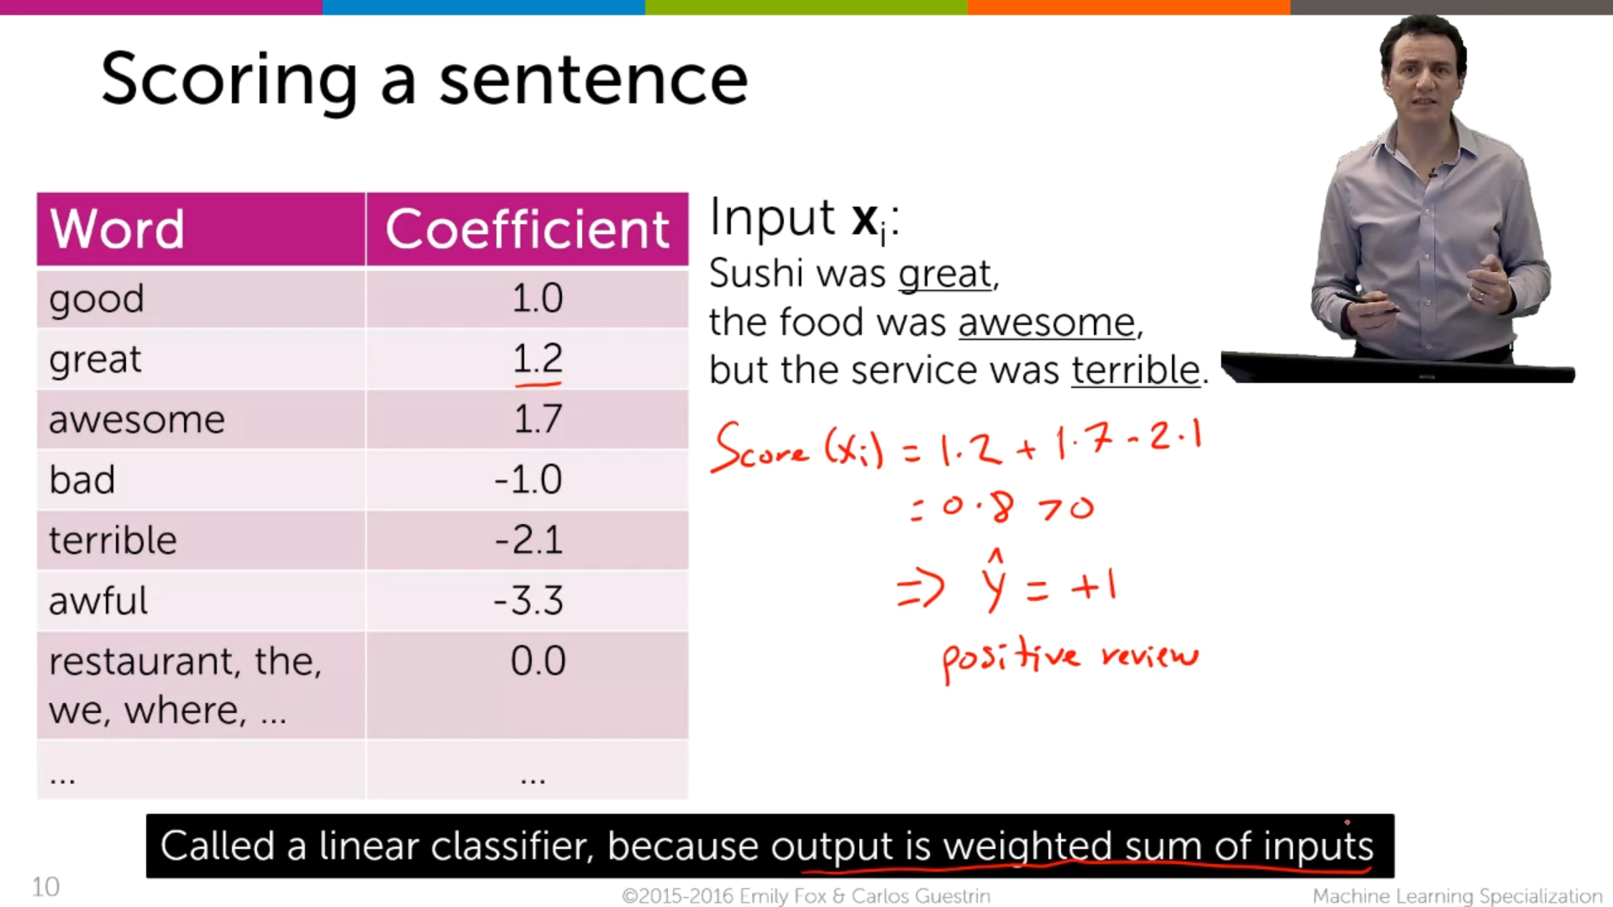

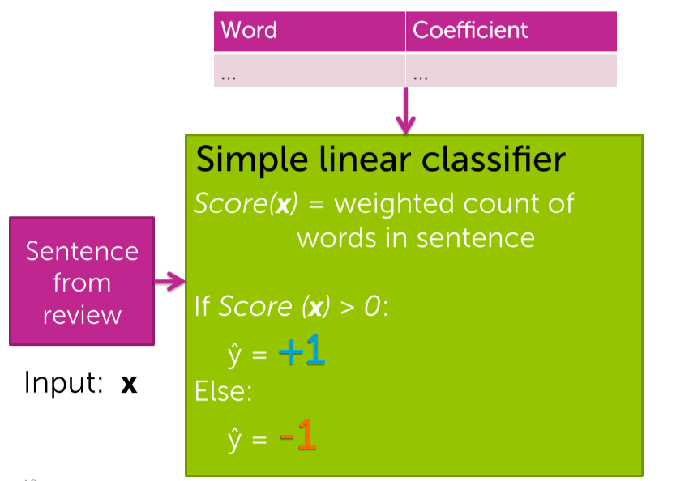

It is the more simplified model for simple linear classifier.

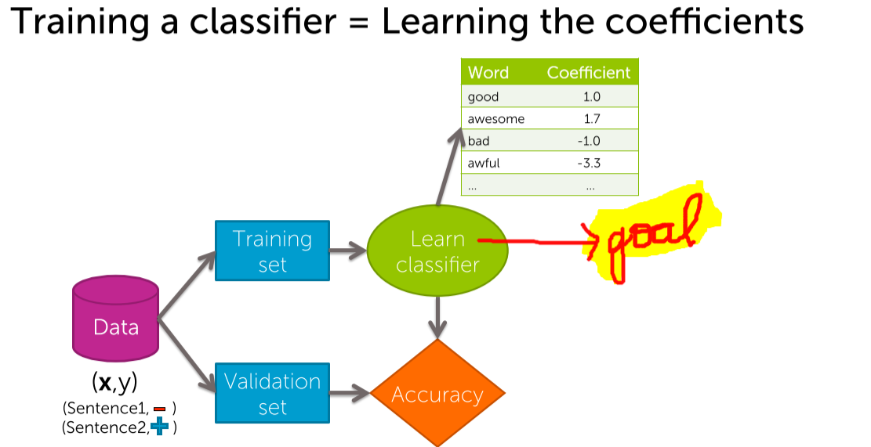

## **Decision boundaries**

Every word has coefficient 0 except #awesome and #awful.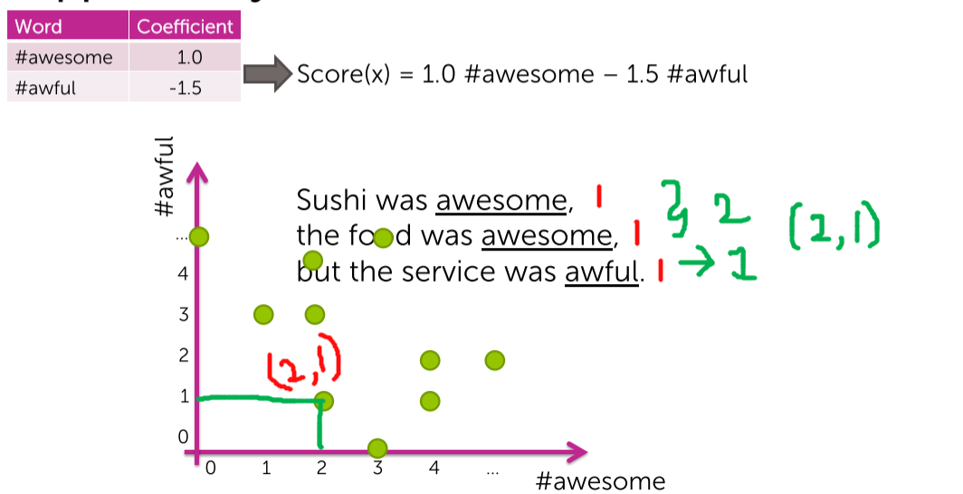

(2 awesome’s ,1 awful) 🡪 plotted.  
Similarly all the data-points are plotted from the data-sets with our fixed coefficient.

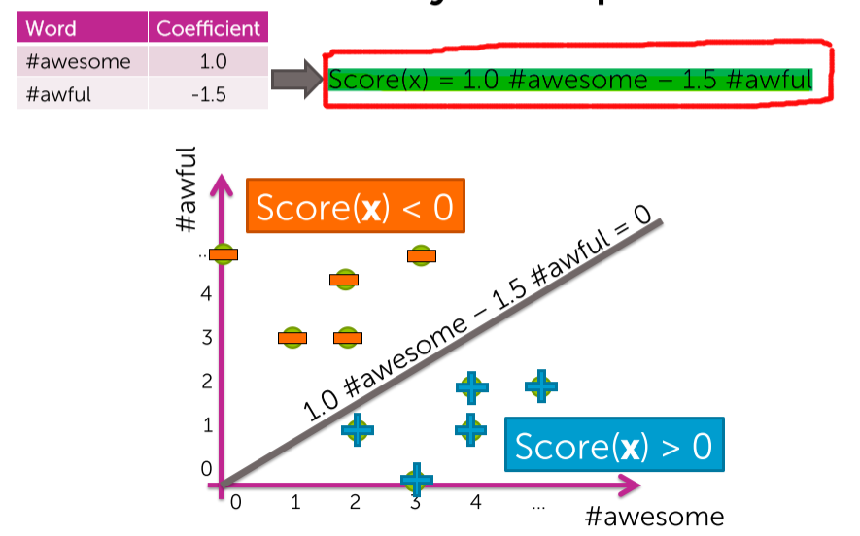

The classifier which we have trained from the data-sets with the coefficients 1.0 and -1.5 will have the decision boundary corresponding to a line.  
1.0#awesome – 1.5#awful = 0  
Score(x)>0 [ below the line ] 🡪 +ve review  
Score(x)<0 [ above the line ] 🡪 -ve review

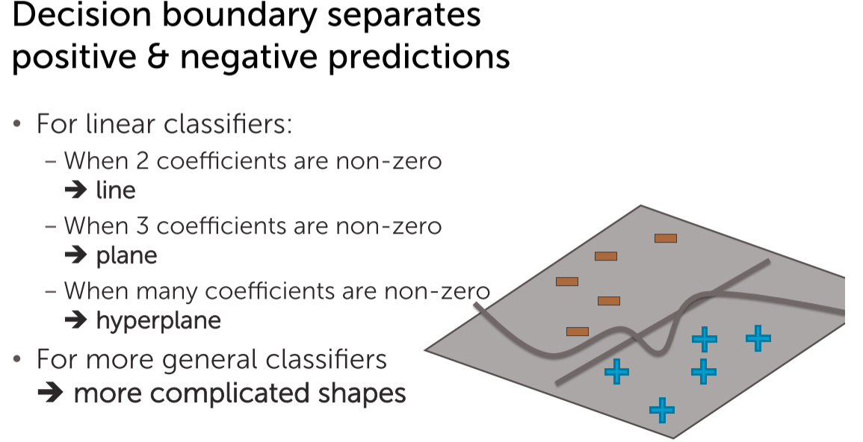

## **Linear classifier Model**

A linear classifier model will try to build a hyper plane (green surface) that tries to separate the positives from the negative examples.  
The hyper plane is associated with the score function i.e Score(x).

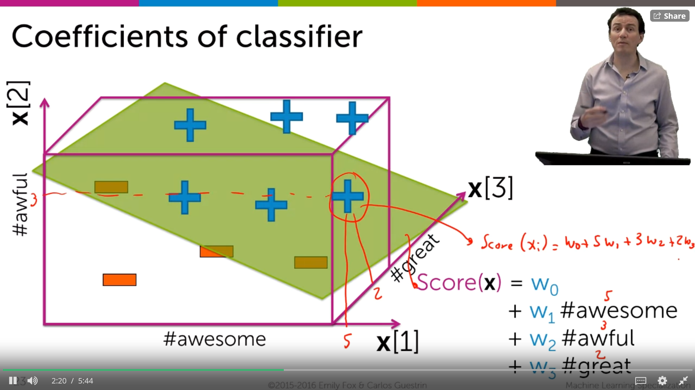

Depending upon the coefficients the score may be +ve/-ve. Since this is a positive training example we want to choose the w that makes the score positive.

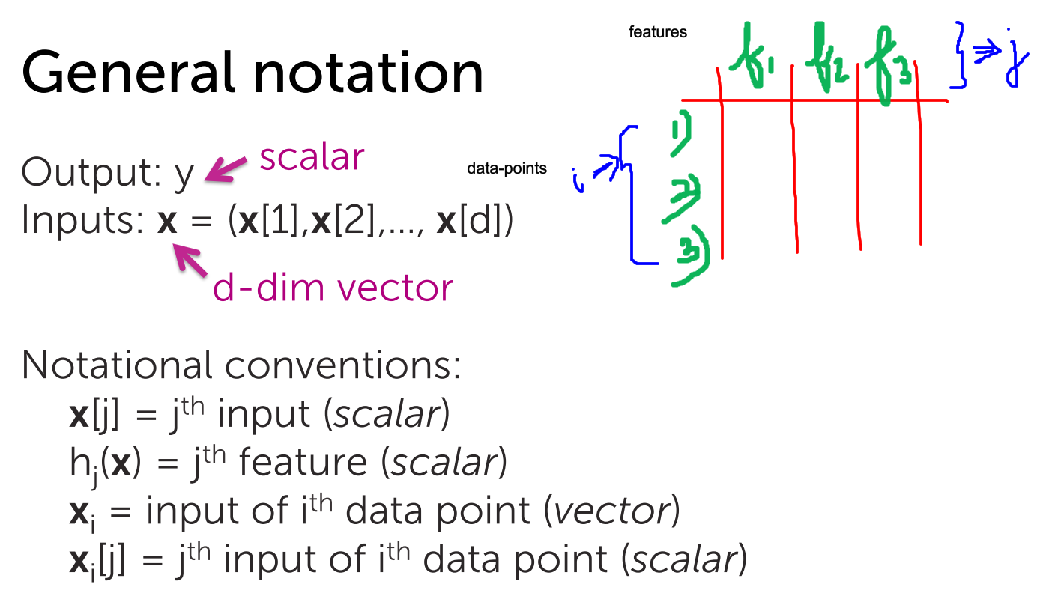   
In Excel features starts from the top and then the data-point.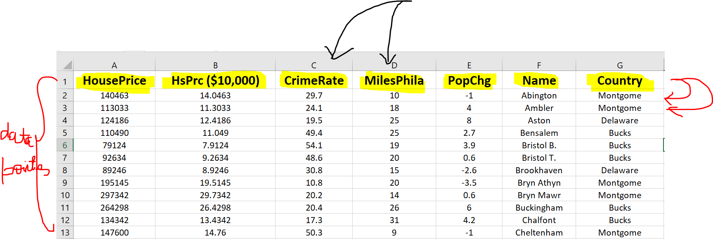

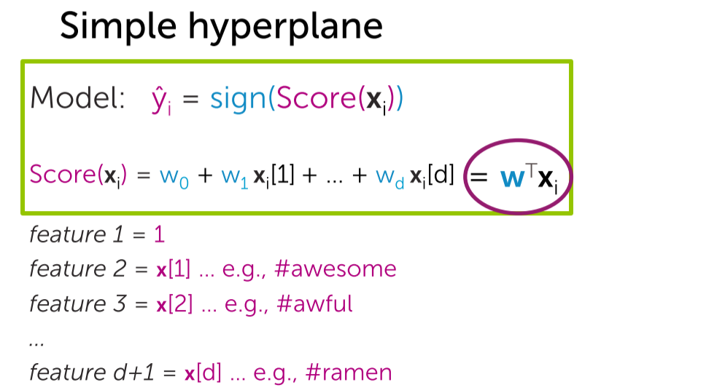

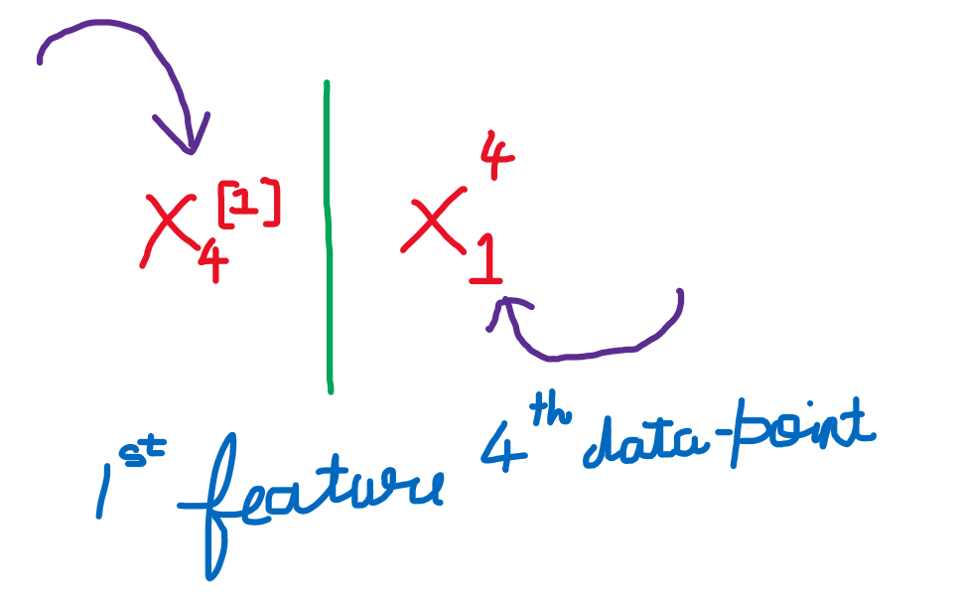

LHS 🡪 feature starts from the stop and then the data-point.  
RHS 🡪 feature starts from the bottom and then the data-point.

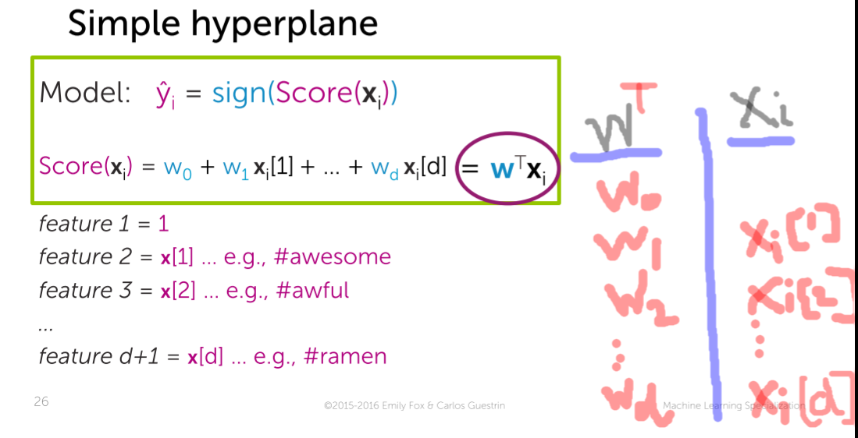



For a single row representing 🡪 xi   
Score for that single row 🡪 score(xi)  
Sign of the score of that single row 🡪 y^(i) = Sign(score(xi))

i from 1 to N (row wise) [xi]

**The Role of *sign***If the score>0 then predict 🡪 +1  
If the score<0 then predict 🡪 -1

At 0, we have the choice to predict either -1/+1. You make an arbitrary choice.

## **Effect of coefficient on decision boundary**

Initially the intercept 🡪 0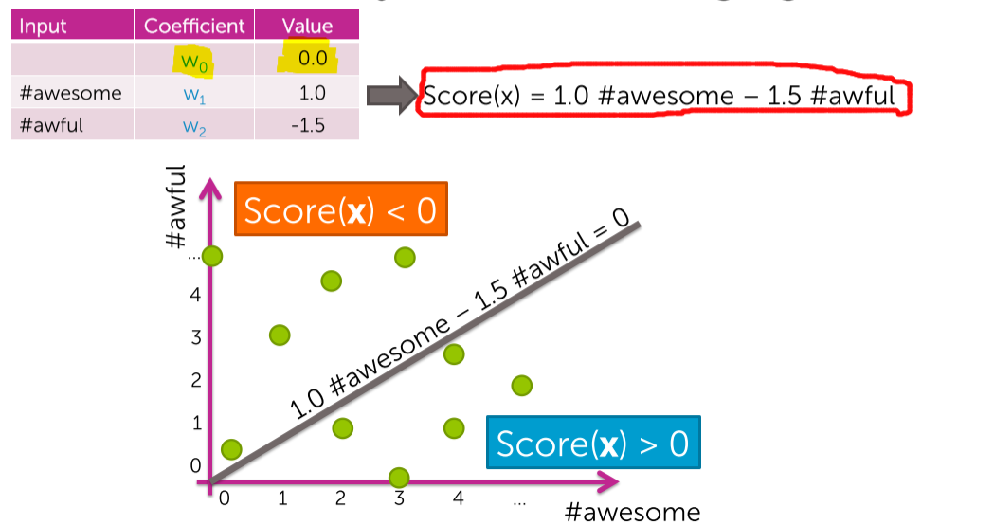

Now the intercept 🡪 1 and the line slightly shifts up, so the orange point which was -ve before, now becomes +ve. 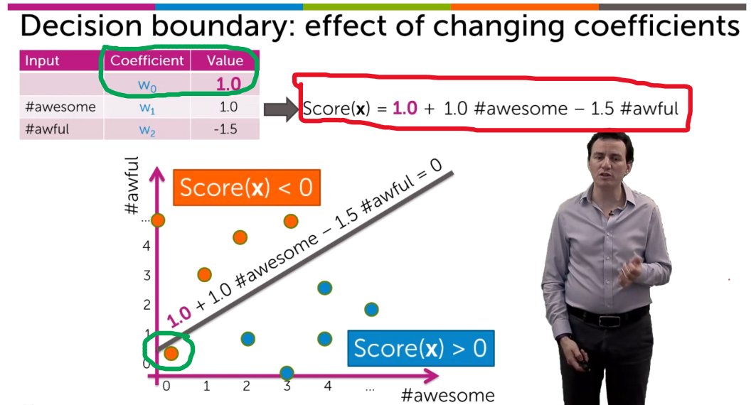

After changing the **w2 = - 3.0**, the line gets modified, and the blue point which was +ve Now becomes -ve. 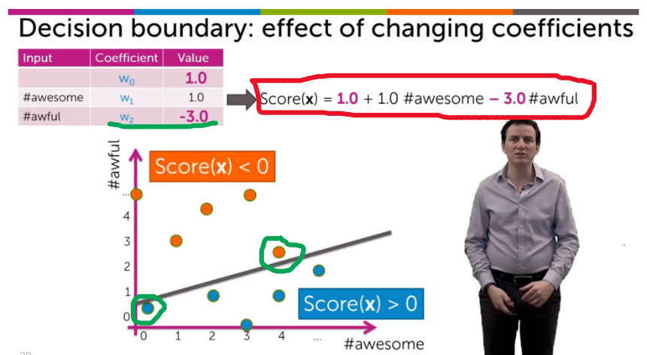

From this we can conclude that the coefficients are playing a very important role in the classification.

## **Using features of the input**

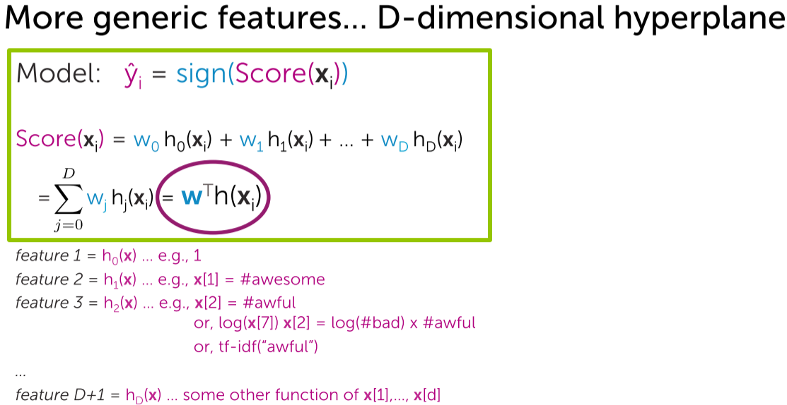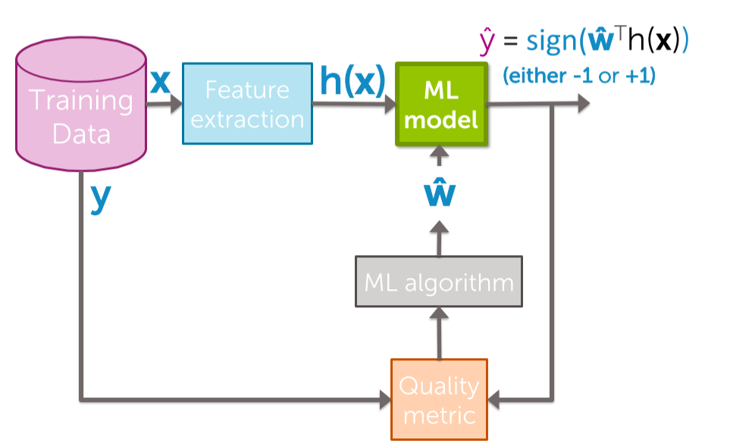

# **Class probabilities**

## **Predicting class probabilities**

Not all our output will be exactly +1 or -1, especially the output of logistic regression will be like 0.432 (or) 0.211. So in-order to conclude them as +1 or -1 (Here probability comes into picture)

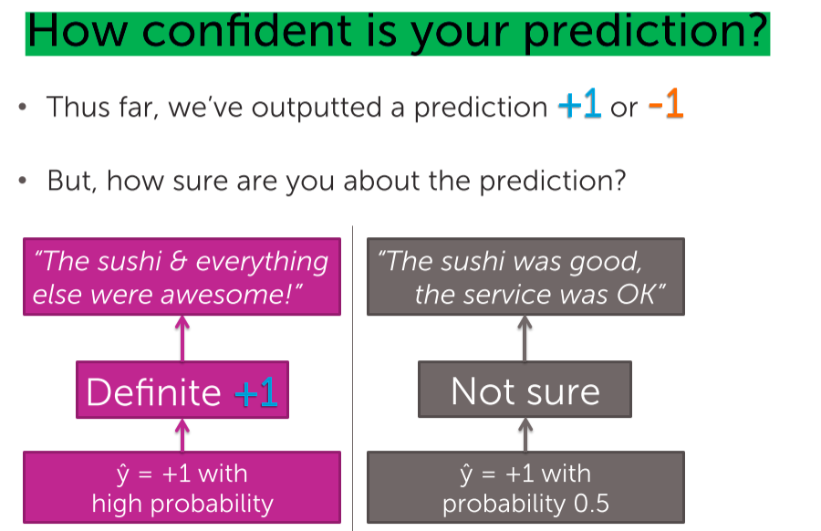

## **Review of basics of probabilities**

What is “Probability thar a review is positive is 0.7” ??  
Ans 🡪 I except 70% rows to have y=+1 (i.e positive reviews)

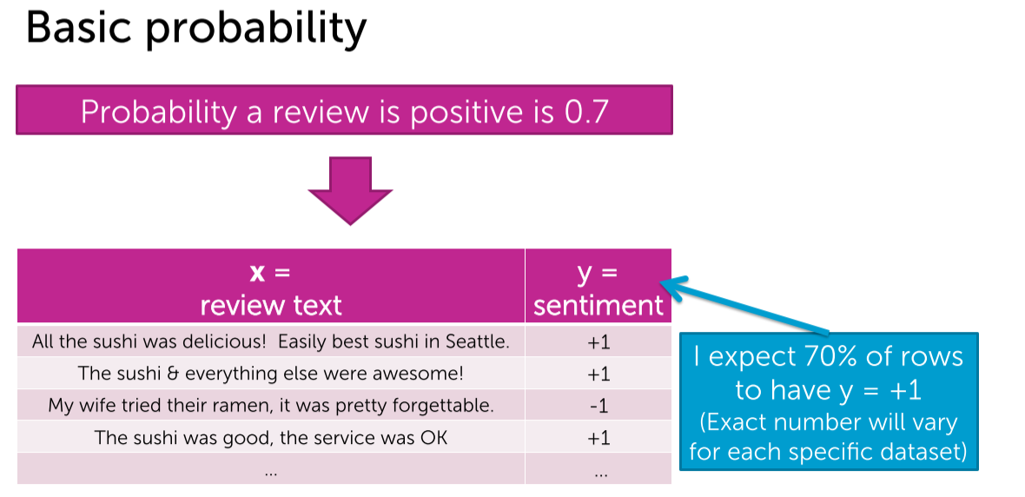  
From the above it is assumed on an average,   
70% 🡪 +ve reviews and the   
remaining 30% 🡪 -ve reviews

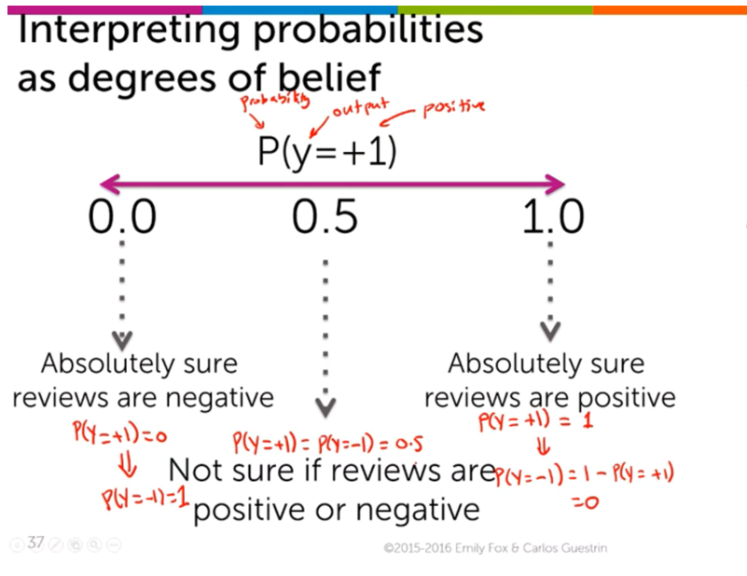

P(y=+1)->1[Complete +ve reviews] , P(y=-1)🡪0 [No negative reviews]  
P(y=-1)->1[Complete -ve reviews] , P(y=1)🡪0 [No positive reviews]

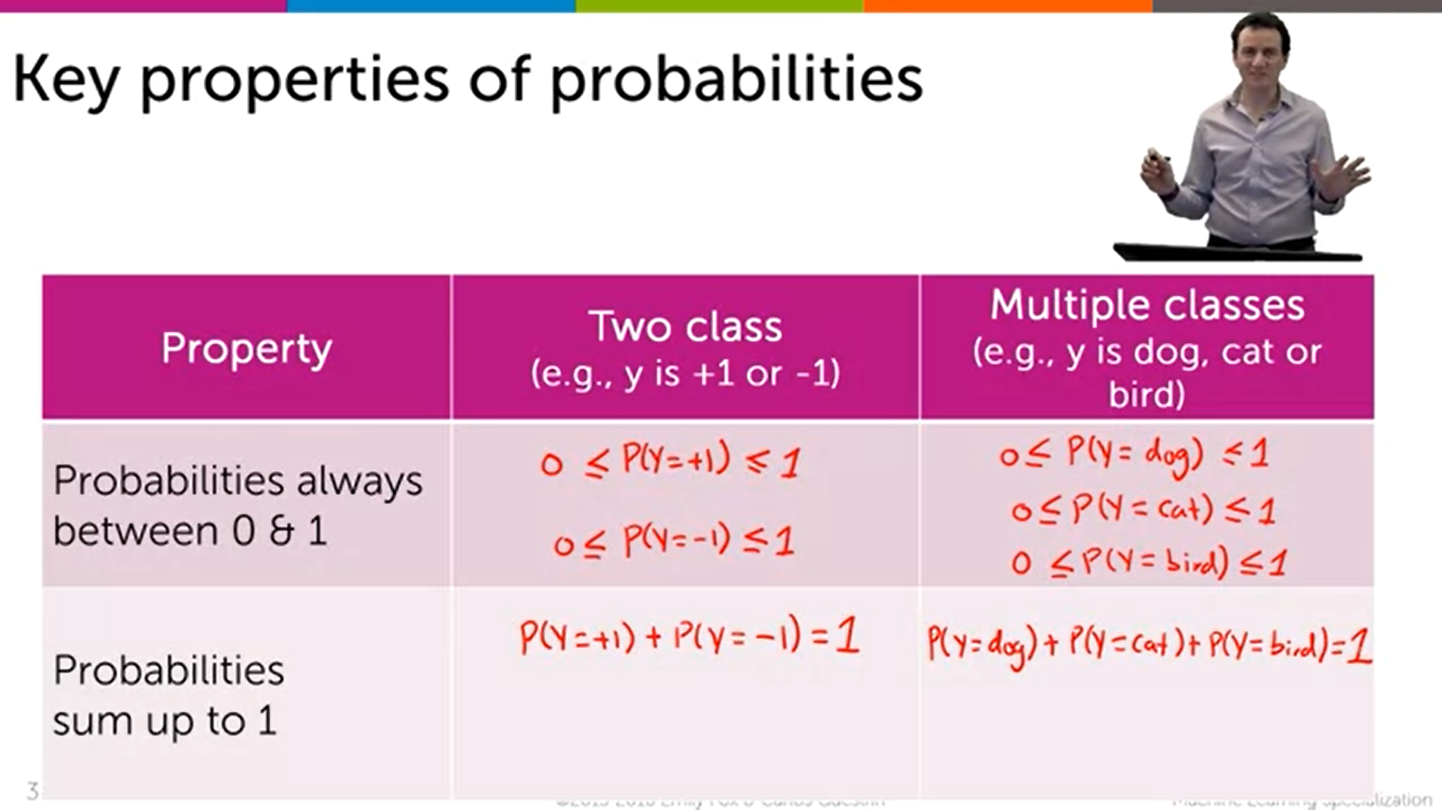

## **Review of basics of conditional probabilities**

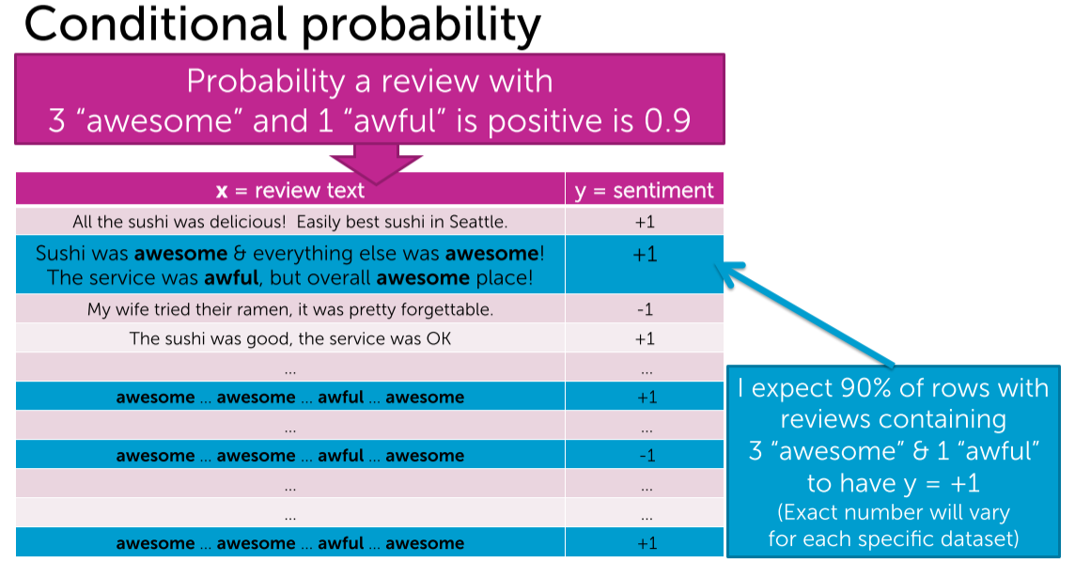

The given condition is that (“3 awesome and 1 awful”). In this given condition, it is observed that 90% of the reviews are +ve and the remaining 10% are -ve.  
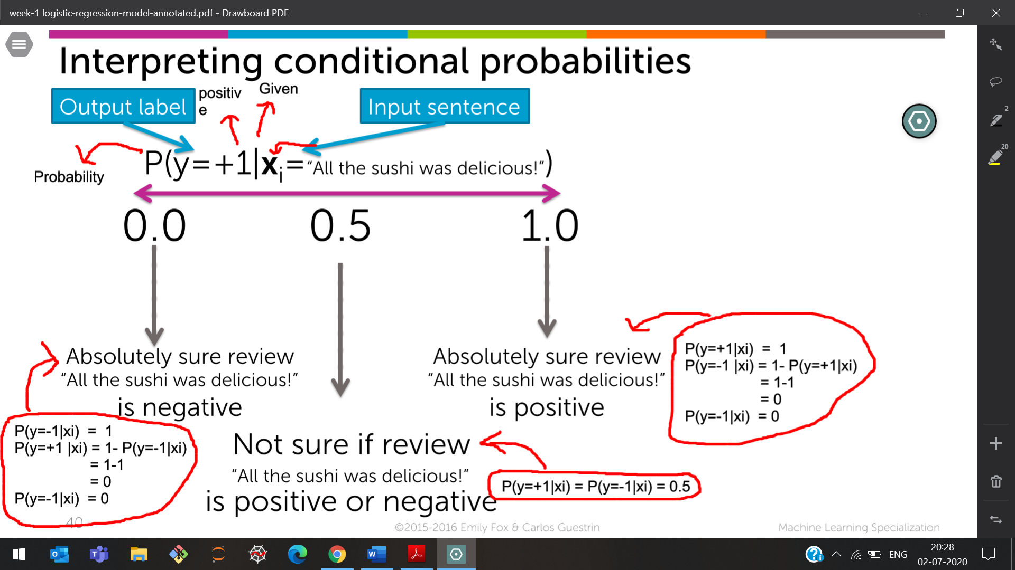

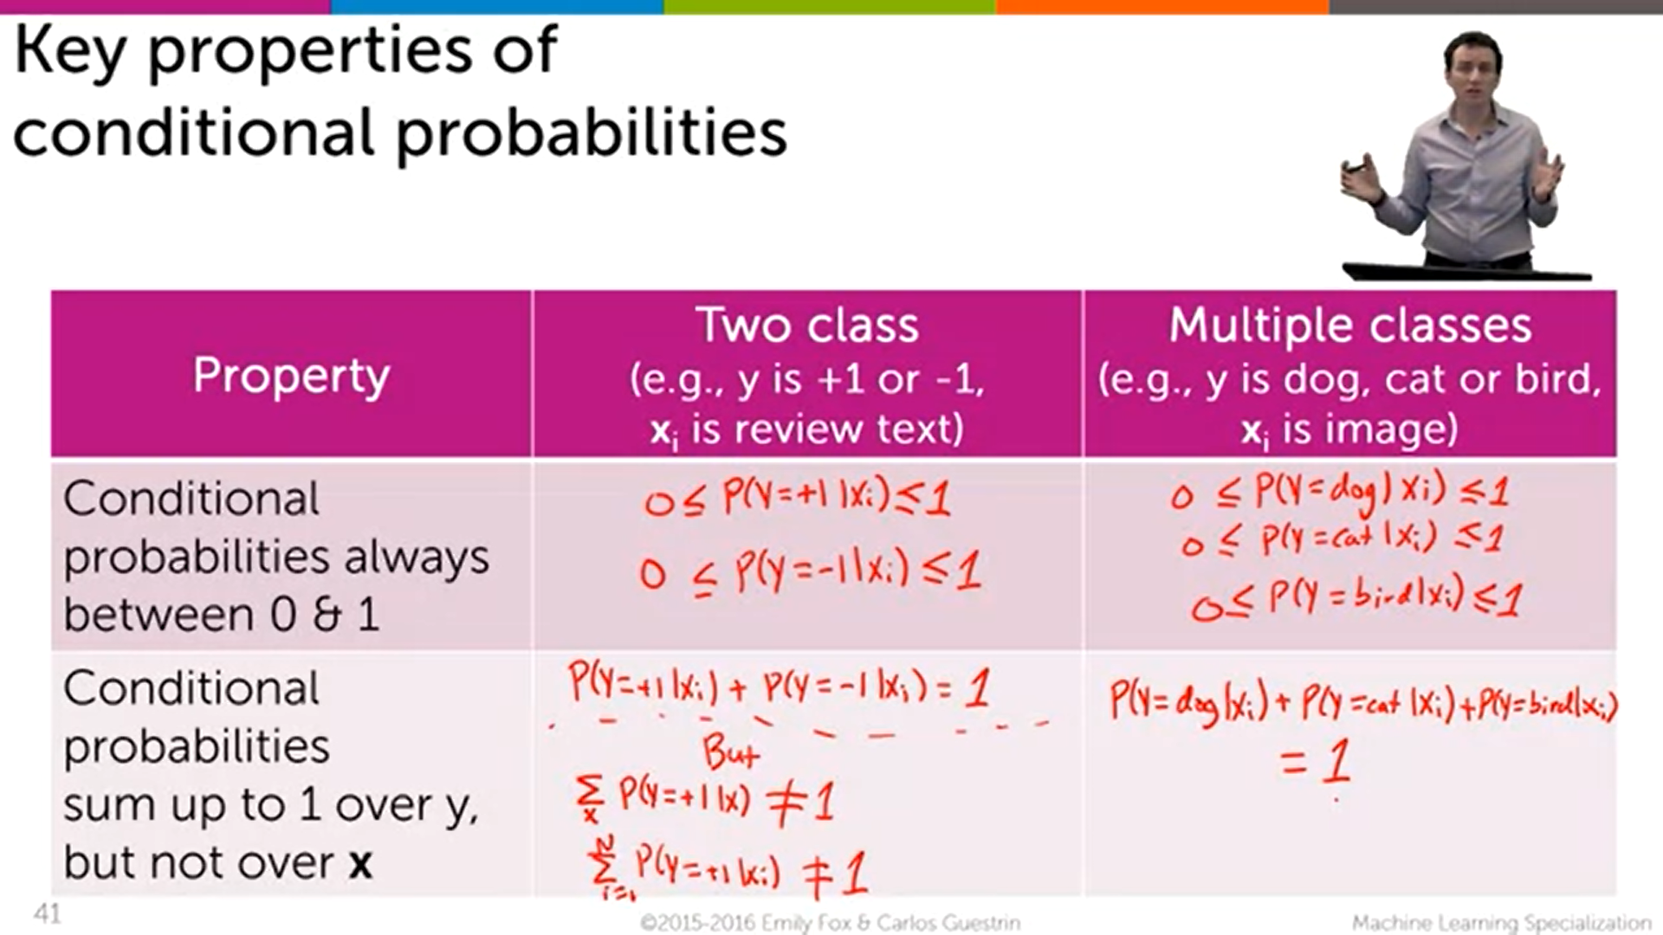

## **Using probabilities in classification**

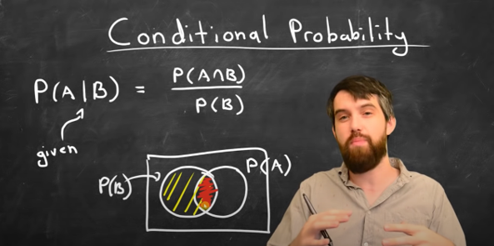

P(A|B) 🡪 The probability of How much A is in B

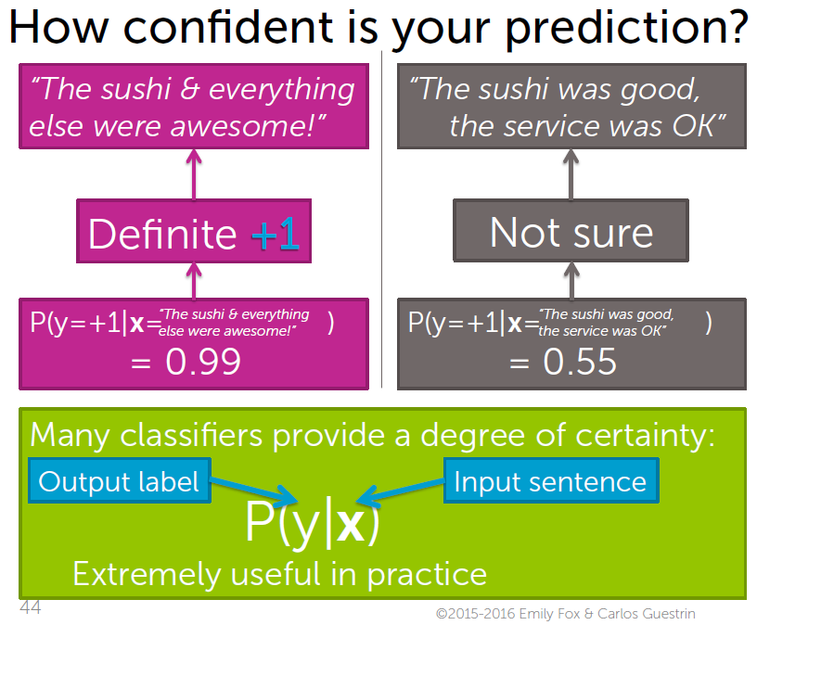

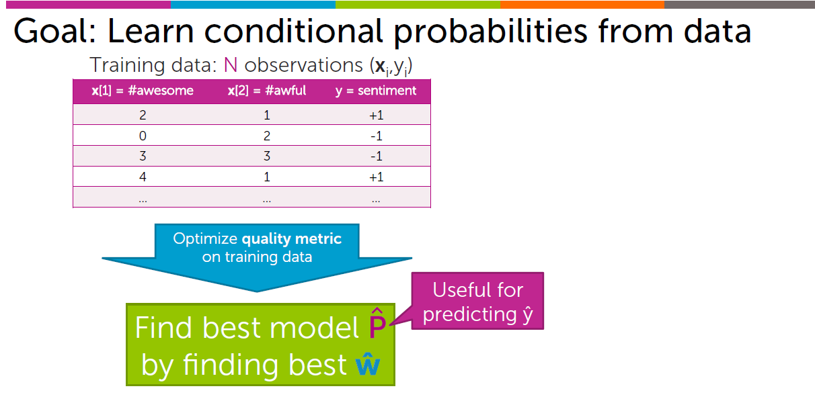

inputs 🡪 Number of awesome’s, awful  
output 🡪 Label for sentiment

These data-sets are used to train a classifier that   
outputs the probabilities/estimate of the prediction 🡪 P^   
which are obtained by the parameters w^/coefficient 2^ of the model.

P^ is used for predicting y^ (which is the predictive class, which in our case is the sentiment for senders).

Before conditional Probability



After conditional Probability

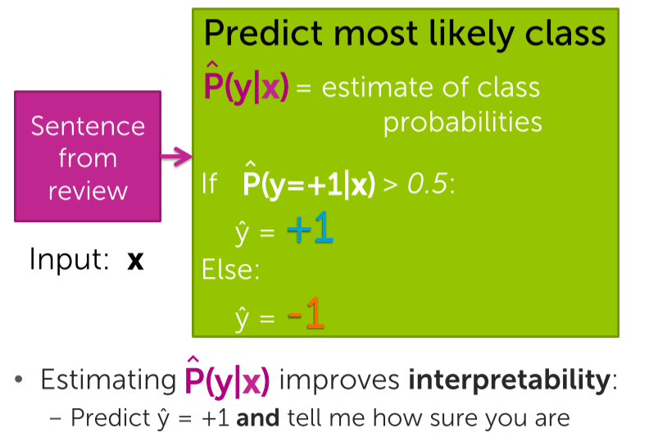

The model is not going to say just plus one and minus one, but

it's going to tell us how sure we are that this is a positive review/negative review.

# **Logistic Regression**

## **Predicting class probabilities with (generalized) linear models**

How to relate the score which falls (-inf to +inf) to the probability (0 to 1) ??

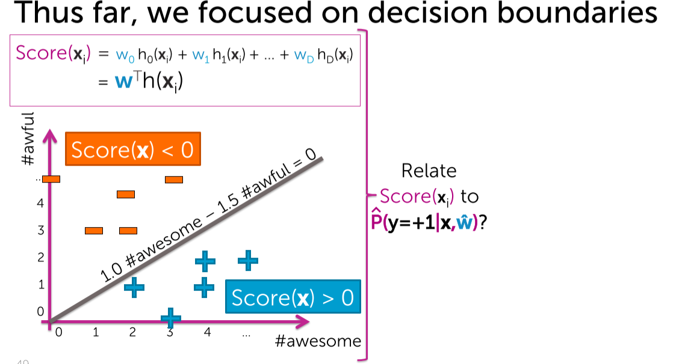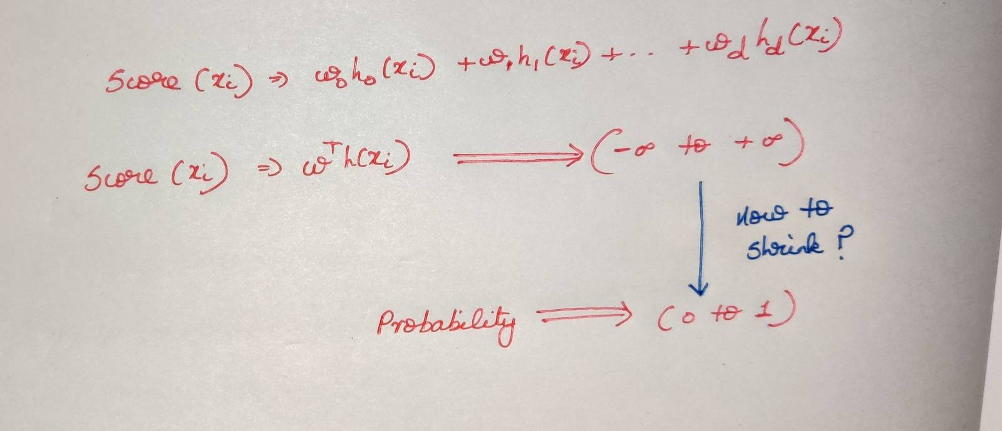

We know below the line the score(x)>0 and   
above the line the score(x)<0.  
But we don’t know how much far is it less/greater than 0.

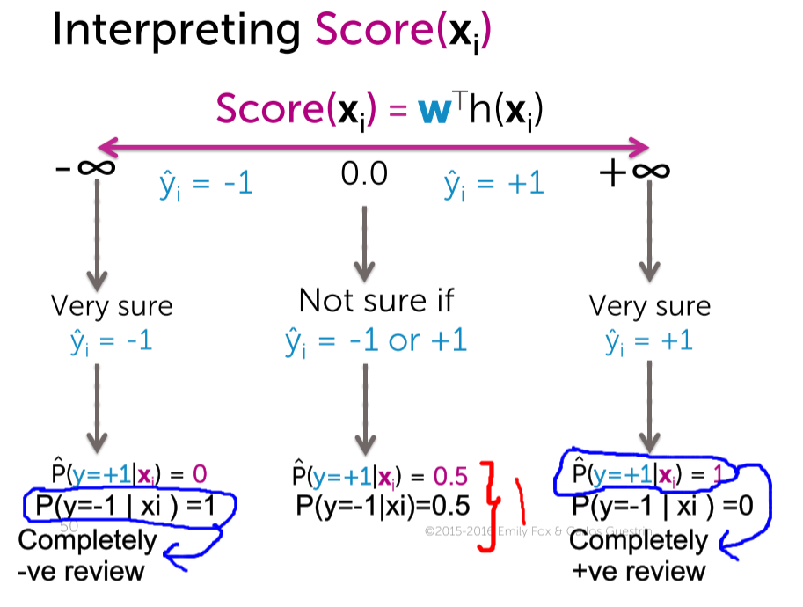

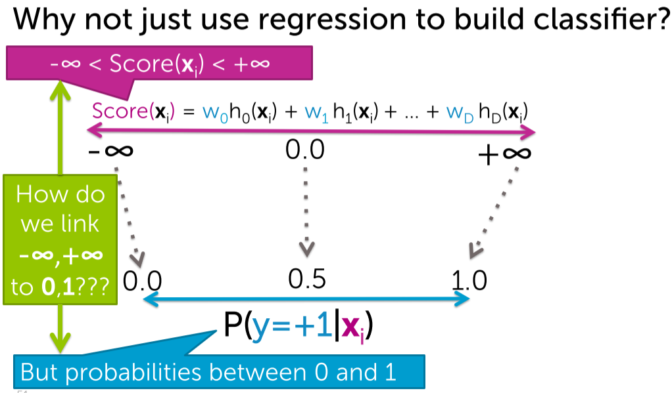

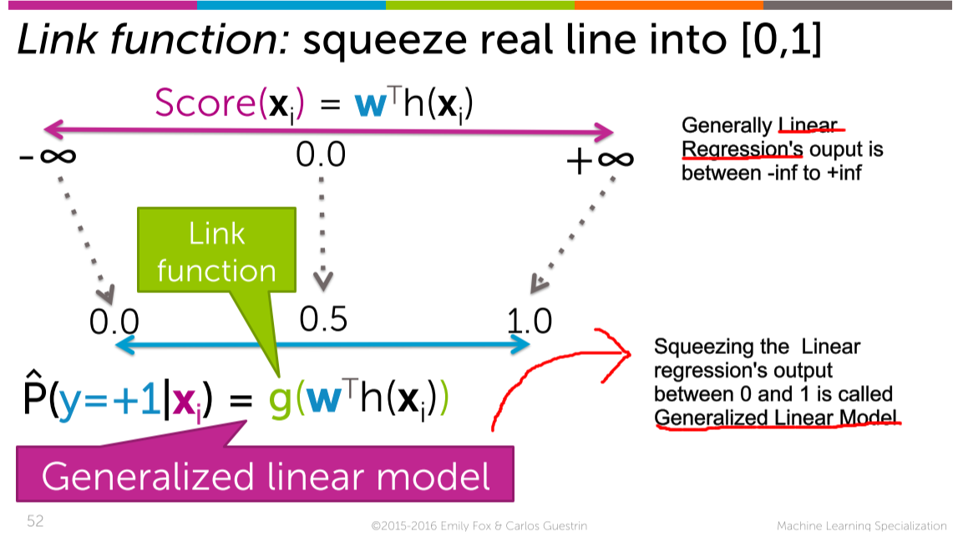



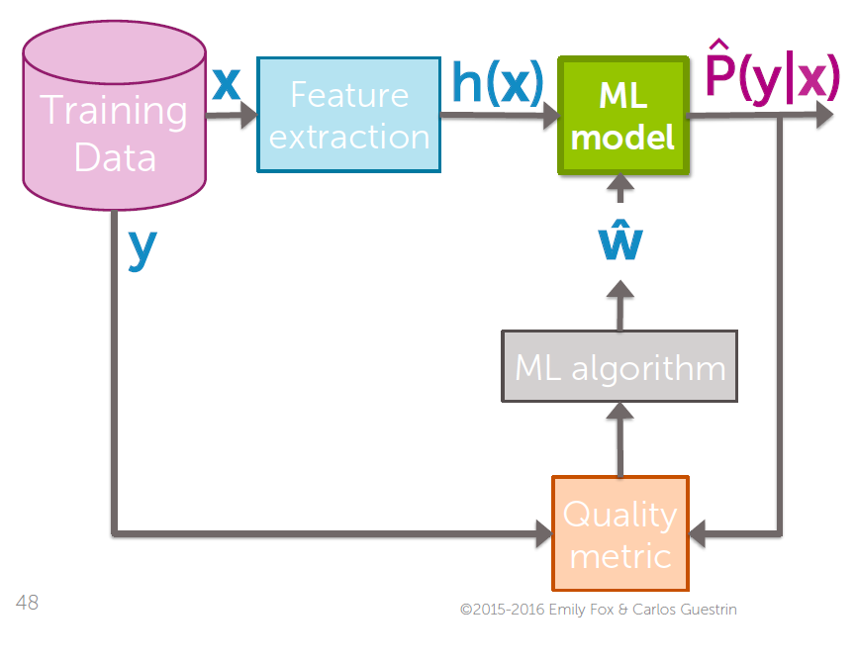 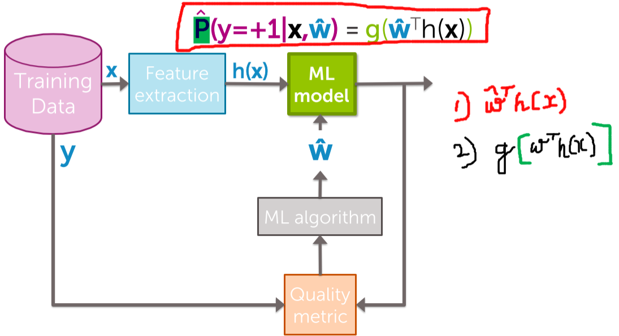



## **The sigmoid (or logistic) link function**

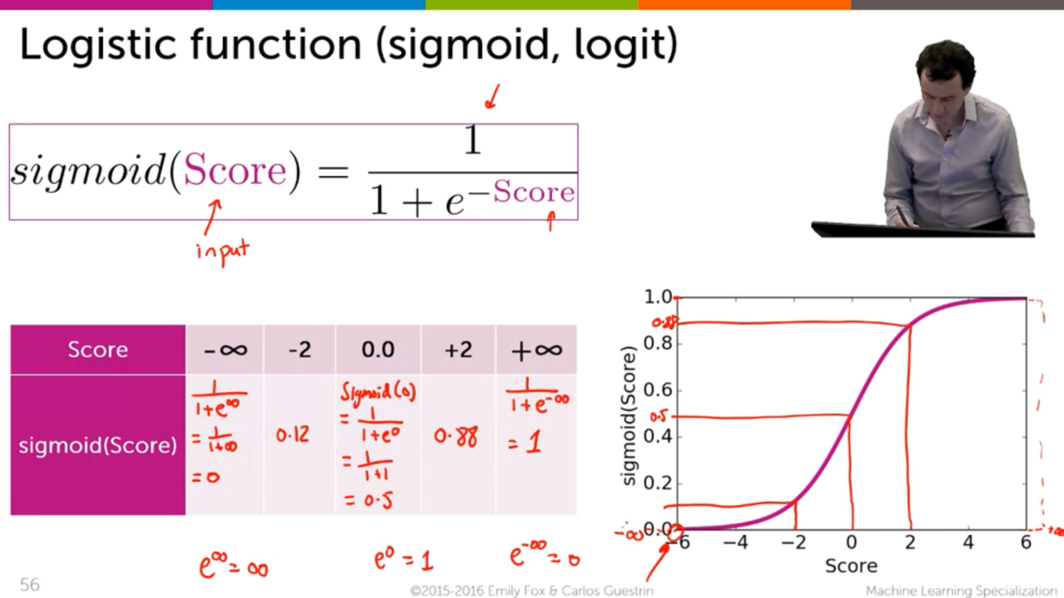

We are giving the score whose output is (-inf to +inf)  
 Wants to change the output (0 to +inf)

This is done using Link function which is Sigmoid function.

## **Logistic regression model**

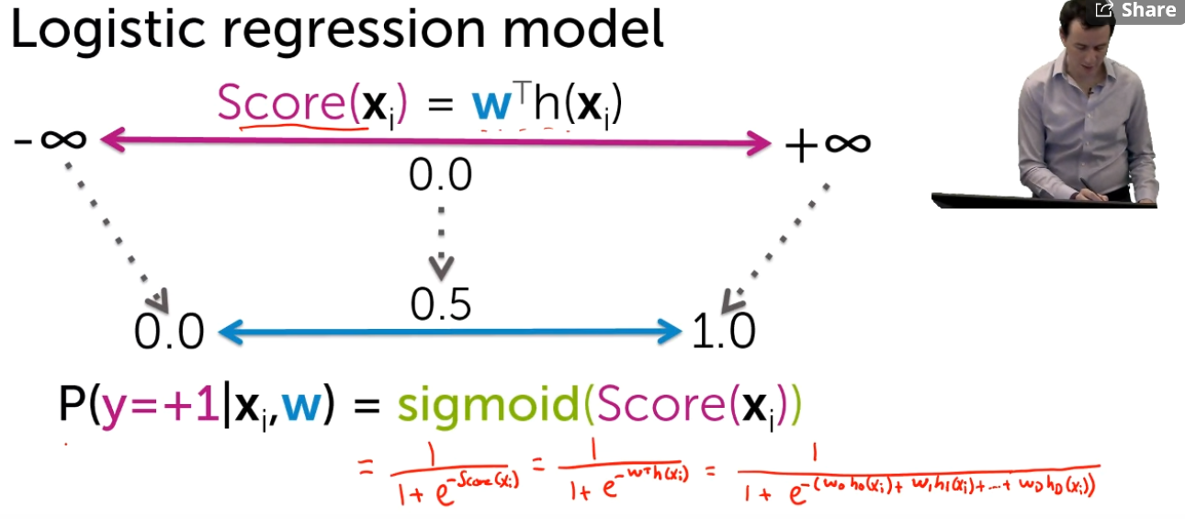

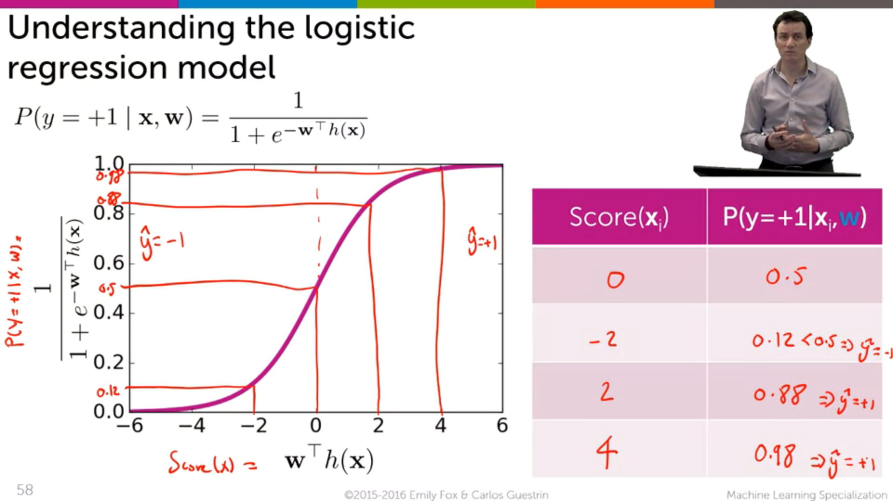



-ve reviews +ve reviews

Taking Score(x-axis) and Probability(y-axis)

## **Effect of coefficient values on predicted probabilities**

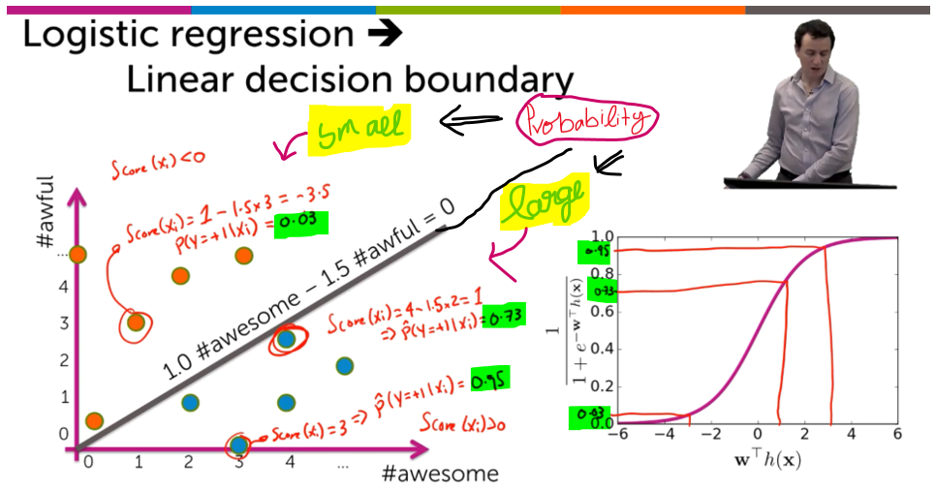

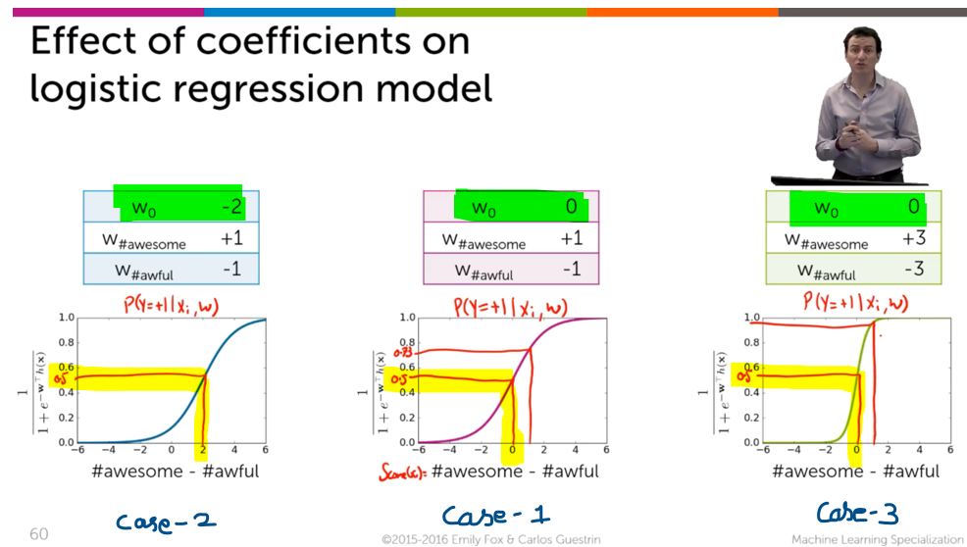

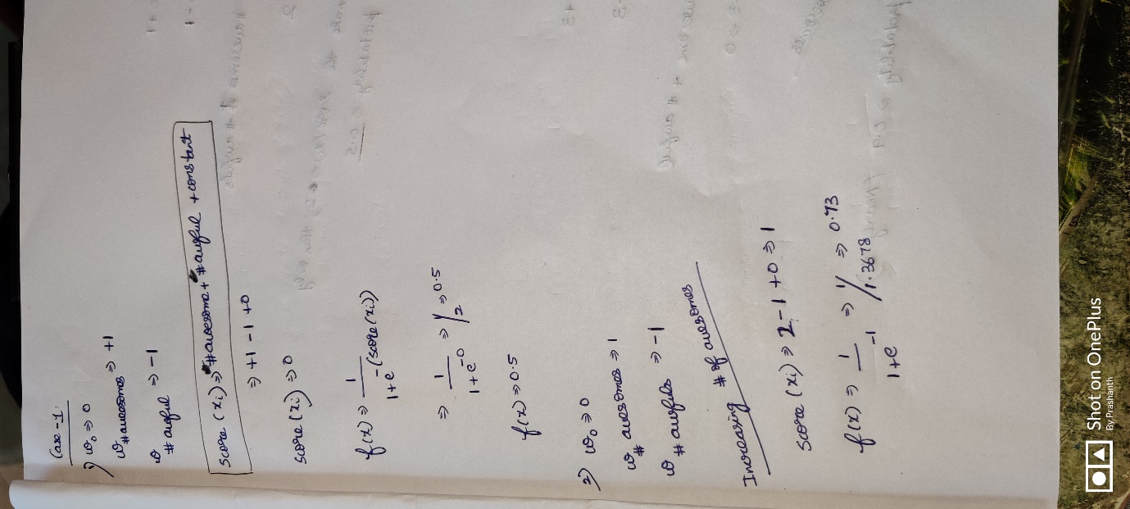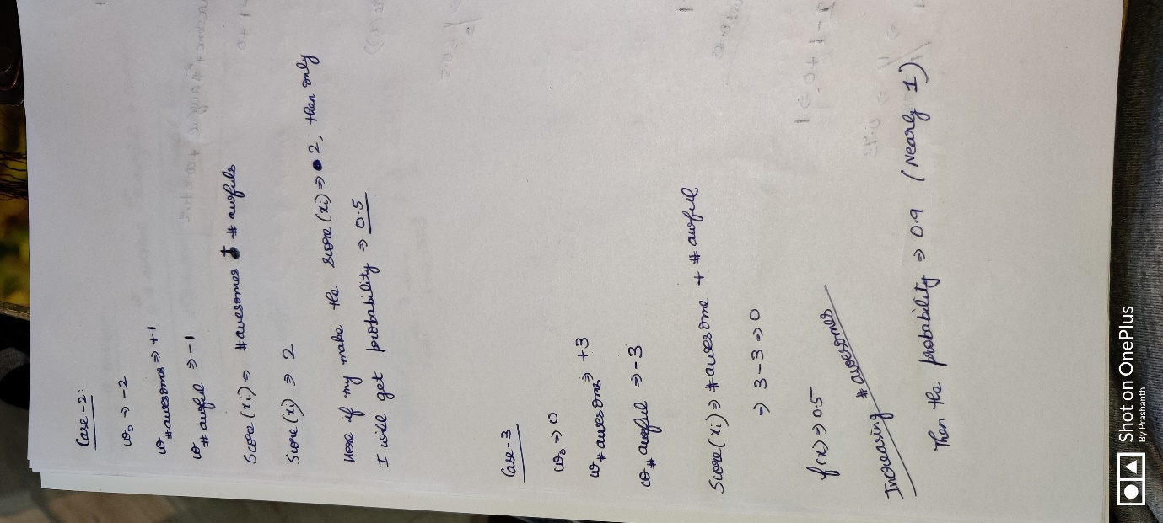



**Conclusion**

* See the effect of coefficients affecting the probability. We can conclude if the model has some bigger coefficients then the probabilities can be found more quickly.
* Changing the constant will shift the line to the left and to the right.

## **Overview of learning logistic regression models**

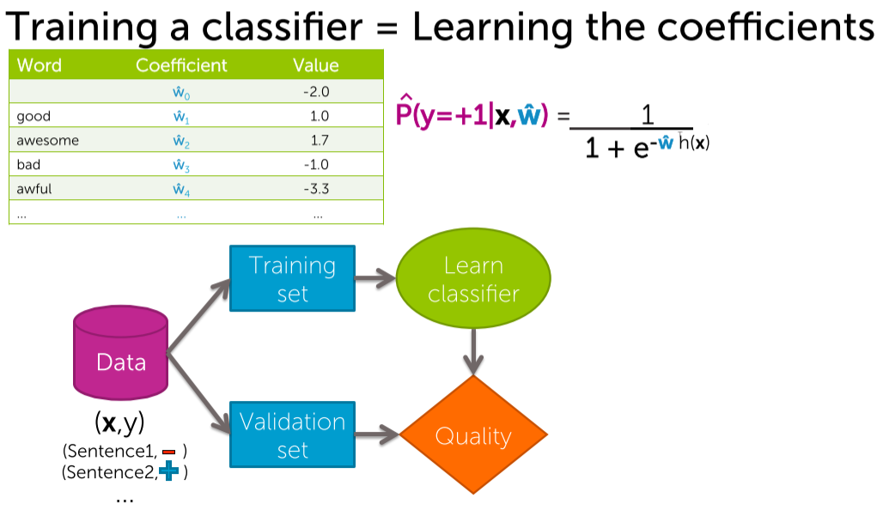

* On the learning data-set we are going to run a learning algorithm (i.e Learning classifier) that will output the parameter estimate w^.
* These w^ are going to be plugged into the model to estimate that whether an input sentence is +ve/-ve.
* The Learning model can also take the validation set and estimate how good it is, what the quality metrics are, what the error is.

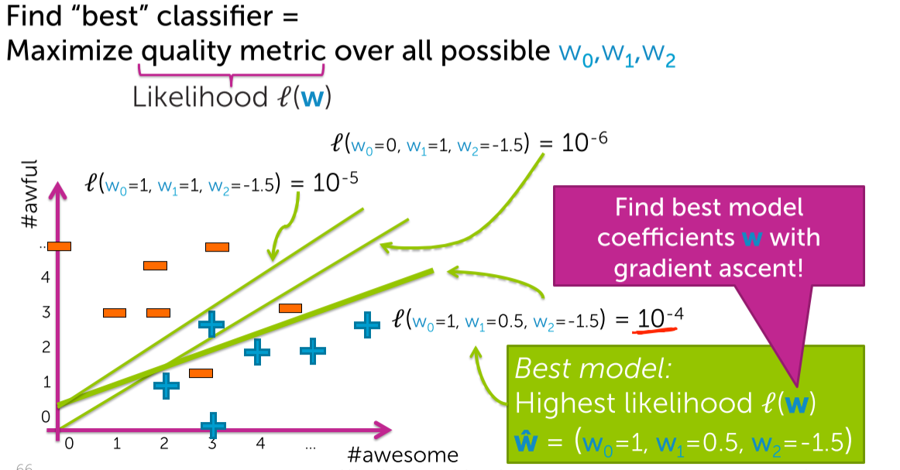

For the best classifier 🡪 quality metric (i.e likelihood function) must be maximized.  
What is the likelihood function l(w) ???  
After that only we can run the gradient ascent. Since we want to maximise the likelihood function.

# **Practical Issues of classification**

## **Encoding the categorial inputs**

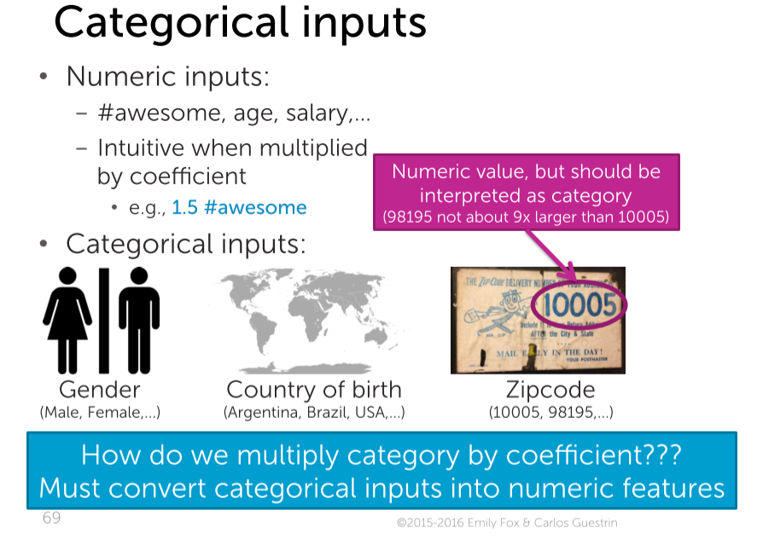

Basically in numerical data,   
in score function 🡪 we will multiply the numeric with the coefficient.

The zip-code is 10005,98195 etc. It is not meant that 98195 is 9 times of 10005. These are different postal codes representing different parts of the country. Hence they are not numerical features, they are categorical features.

But how to multiply the coefficient with the categorical values???  
This is achieved by **encoding technique.**

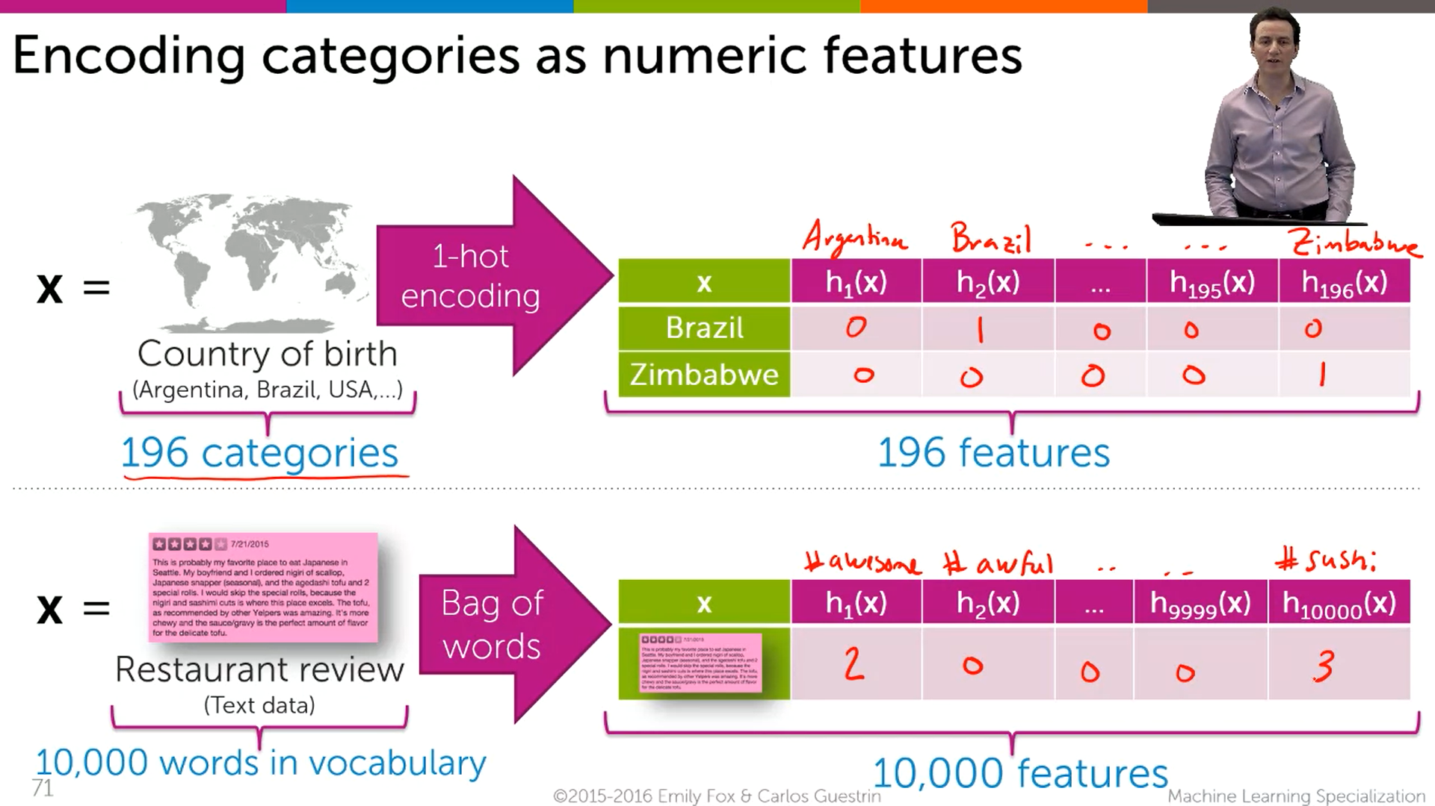



If somebody is born in Brazil 🡪 then for Brazil put 1 and for everything put 0.  
If somebody is born in Zimbabwe 🡪 then for Zimbabwe put 1 and for everything put 0.



How to encode a restaurant’s review???  
Take 1 review, and put down the word count in the respective places  
In the above case , 1st review contains (2 🡪 awesome) , (0 🡪 awful) ,…,(3🡪sushi)

In both the cases we have taken the categorical feature and defined a set of features one for each possible category, to contain either a single value on or account. And we can feed this directly into the logistic regression model.

## **Multi-class classification with 1 versus all**

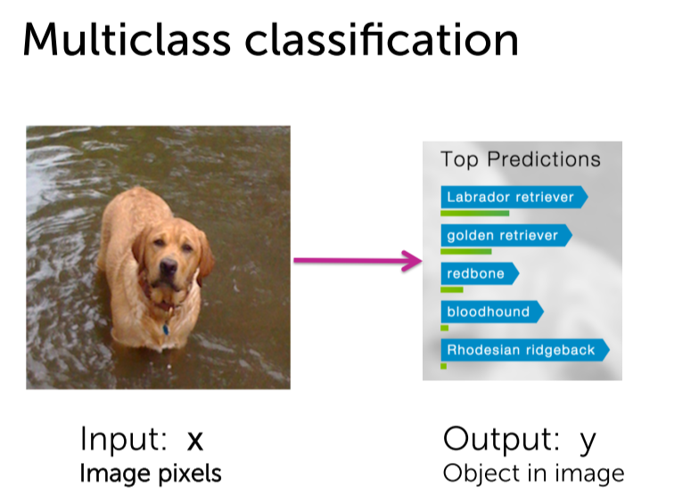

In this image 🡪 there is a dog  
Our aim is to predict 1) Whether is it a dog ?? 2) What kind of dog is it???  
Here we are not having only 2 categories . There a nearly 1000’s of categories.

Eg: Triangle, donut and hearts are different classes.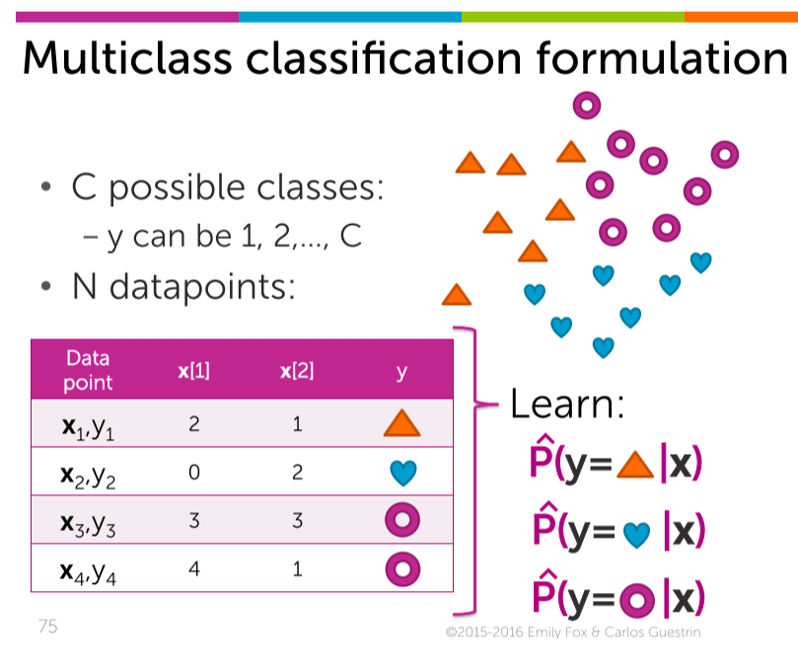  
There are 3 classes, What I need to know is for a particular input,  
Whether is it a triangle, hearts or donut.

Now I want to classify the triangle from the rest.

**How to solve this??? 🡪 One versus ALL**

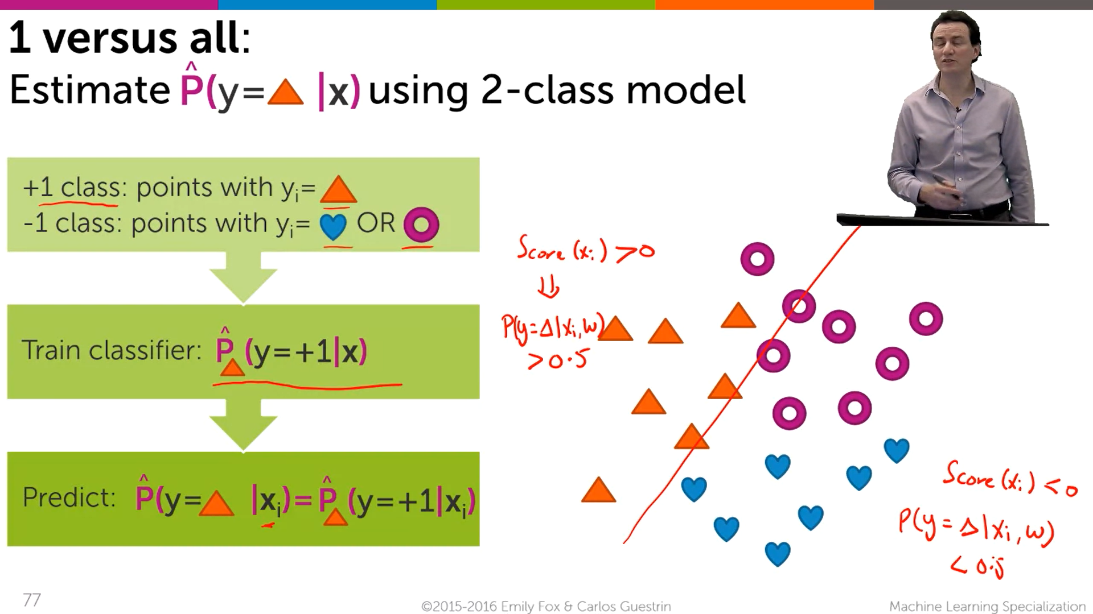



Now we are going to make a classifier to learn 🡪 that separates the triangle from the donuts and hearts. This train classifier outputs +1, if the input x is more likely to be a triangle.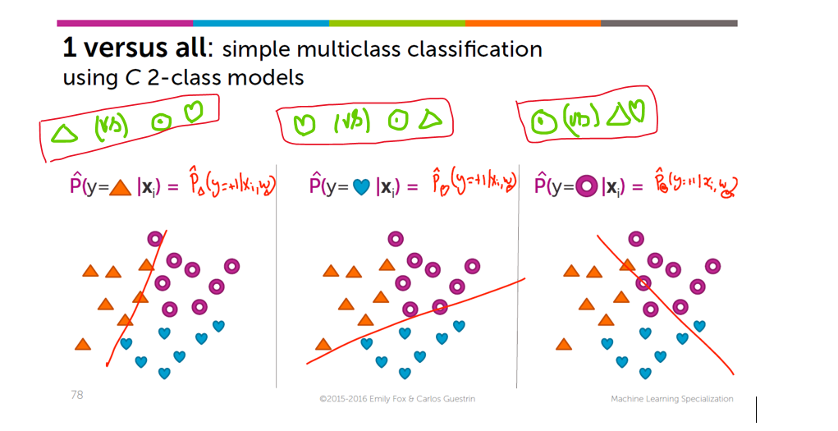  
In the same data-set  
1st  classifier 🡪 triangle . Note down the probability.  
2nd classifier 🡪 hearts. Note down the probability.   
3rd classifier 🡪 donot . Note down the probability.

Among these three classifier , capture a classifier which has the highest probability. For eg: If the 2nd classifier (i.e heart classifier) has the highest probability means that classifier ( i.e w (heart) ) make the classification more exact and accurate.

**Take the dog classification example**

Iterate over all the classifier and finally note which classifier has the highest probability and that classifier classifies correctly when compared to the rest of the classifier.

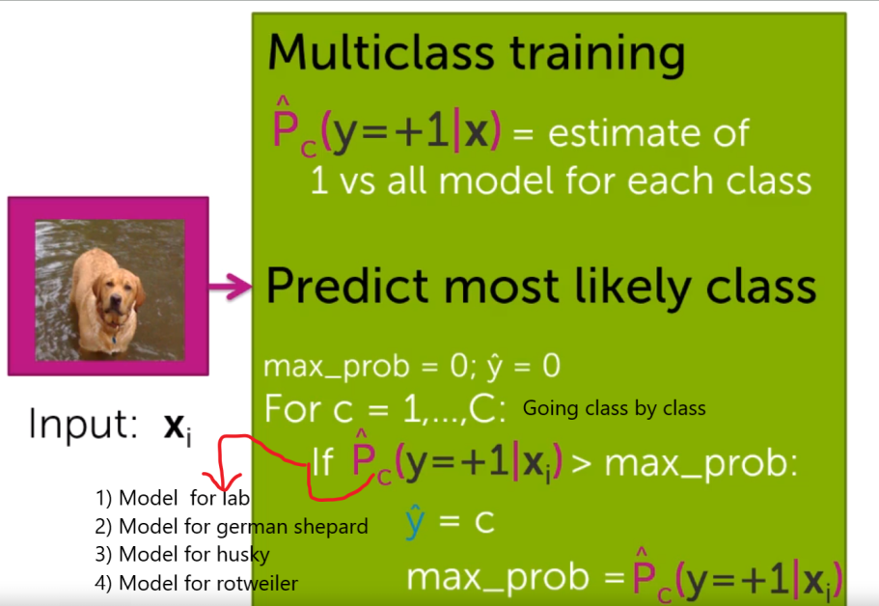

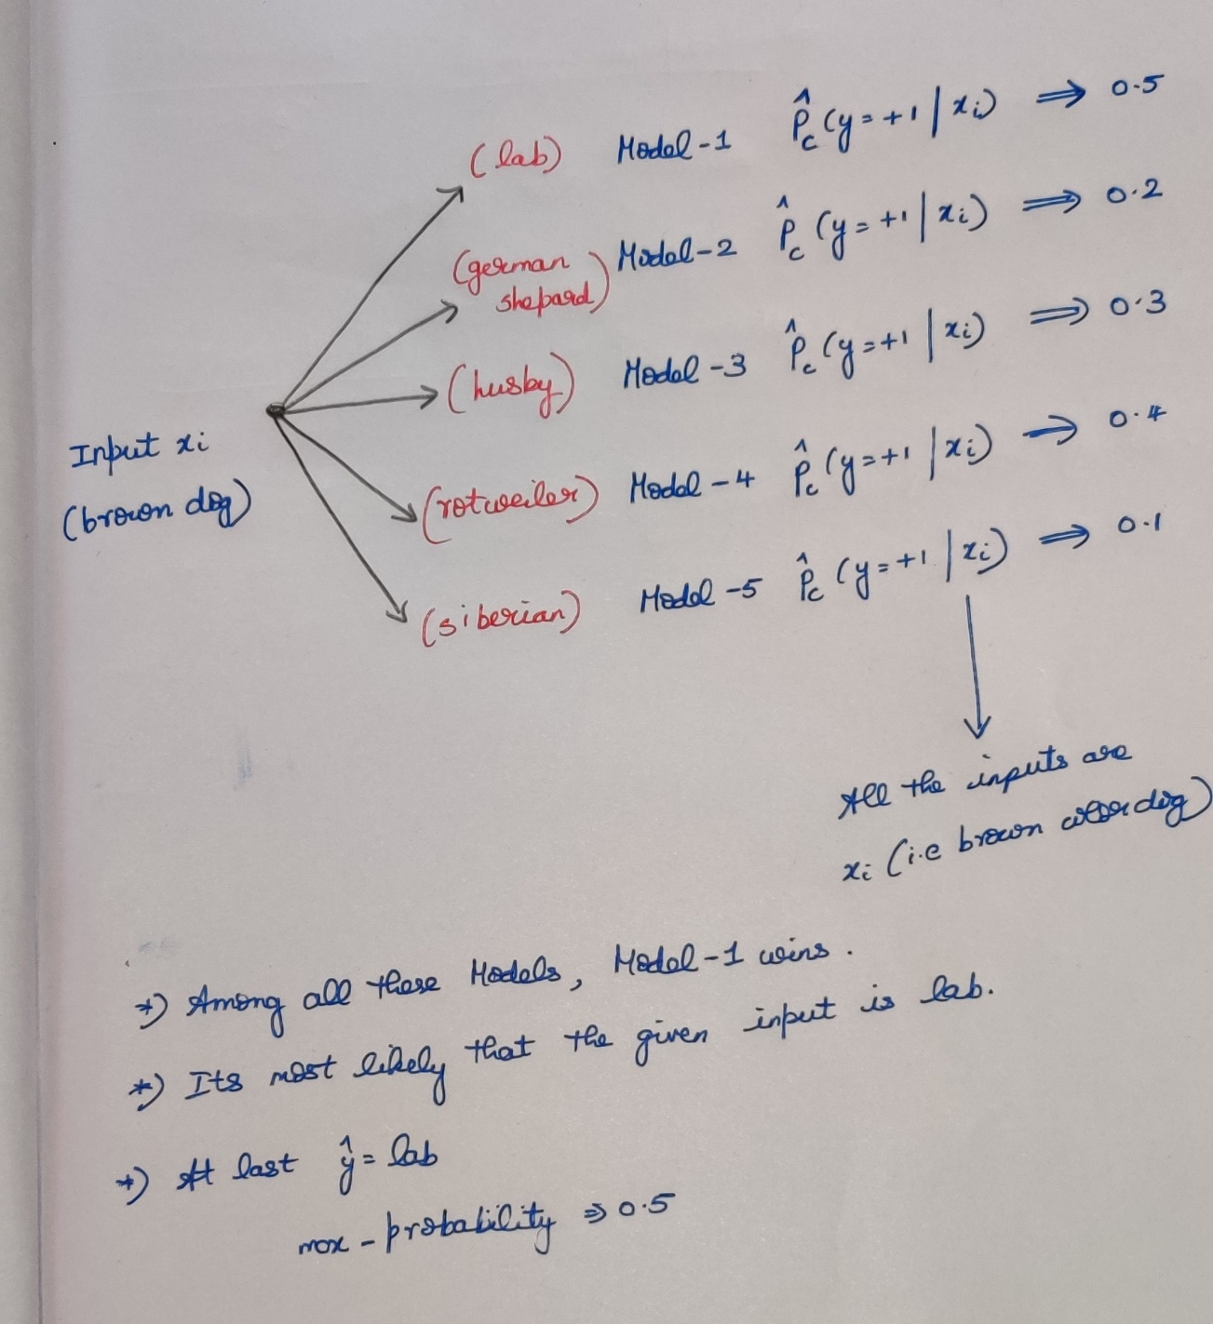

* Train a model for each class. What is the probability that it wins against everything else?
* For a particular input xi (i.e dog image) we are going to compute the probability to the every class estimates and output the maximum.